

|  |  |  |  |  |  |  |  |  |
| --- | --- | --- | --- | --- | --- | --- | --- | --- |
|  | | | | | | | | |
|  | | GROWTH AND EVOLUTION OF FARMERS MARKET IN USA | | | | |  | |
|  |  | | | | | | |  |
|  | | | |  |  | | | |
|  | | | | PRADEEP POONATI |  | | | |
|  | | | | 02/25/2020Computation and visualization IE6600Sri Radhakrishnan |  | | | |
|  | | |  | | |  | | |



|  |  |  |  |  |  |  |  |  |
| --- | --- | --- | --- | --- | --- | --- | --- | --- |
|  |  | | |  |  | | |  |
|  | FARMERS MARKET | | | | | | |  |
|  |  | | |  |  | | |  |
|  |  | |  | | |  | |  |
|  |  |  | The Below report shows the insights of farmer markets spread over the United States of America which are obtained by cleaning analyzing and visualizing the Farmers Market data gathered from 2012 to 2019 by using R | | |  |  |  |
|  | | | | |
|  |  |  |  |
|  |  |



**Insights of Framers Markets based on Geographical locations**

**Top 10 states with highest number of farmers markets**

1.The below Bar Chart shows the top 10 states with higest number of farmers markets where the California has the highest number of Farmers markets (i.e >700) when compared to other states and New York stands second

2.70% of the states has the farmers markets less than or equal to 200 markets.

3.michigan, Illinois and Florida ,Virginia has almost same number of markets i.e ~340 and ~260 respectively

4.Least number of Farmers markets are present in Virgin Islands

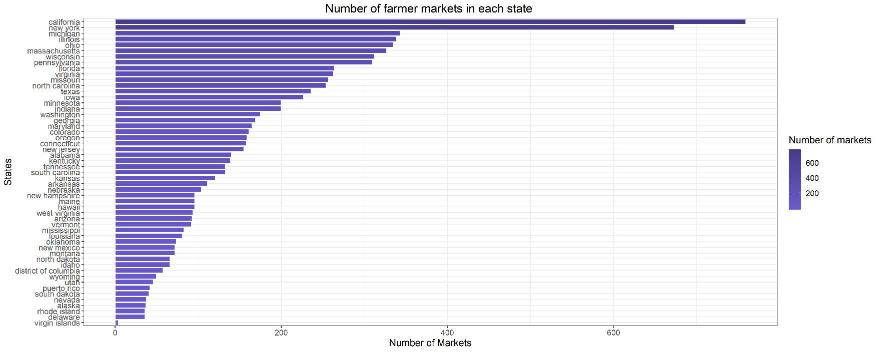

**Number of markets in each Region**

1. The below plot shows that the greatest number of farmers markets present in Midwest region followed by south east region
2. Since the states like Minnesota ,Missouri, ,Ohio, Illinois, Wisconsin present in top 10 states with highest number[1] of farms and these states resides in Midwest region which is why the number of farmer markets are high in that region.
3. US Territories & south west region has the lowest number of farmers markets.
4. Though the California is the state with highest farmers markets west region stays below middle Atlantic .

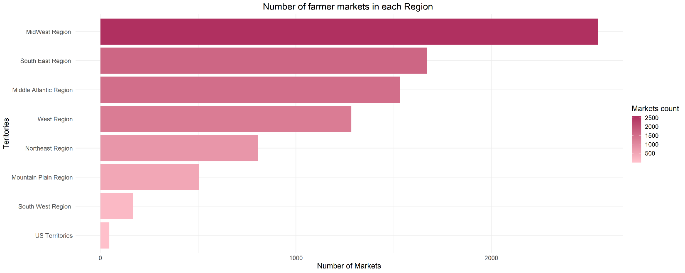

**Farmers Markets per residing Area**

1. Below Bar Graph shows the insights about the areas where the market is located
2. From the results we can say that the mostly markets are situated in local government Building Grounds, this shows the supportiveness of government towards improving the Framers Markets
3. The results show farmers are least interested in setting up their markets near wholesale market facility as the customers will go for wholesale markets due to their cheap prices

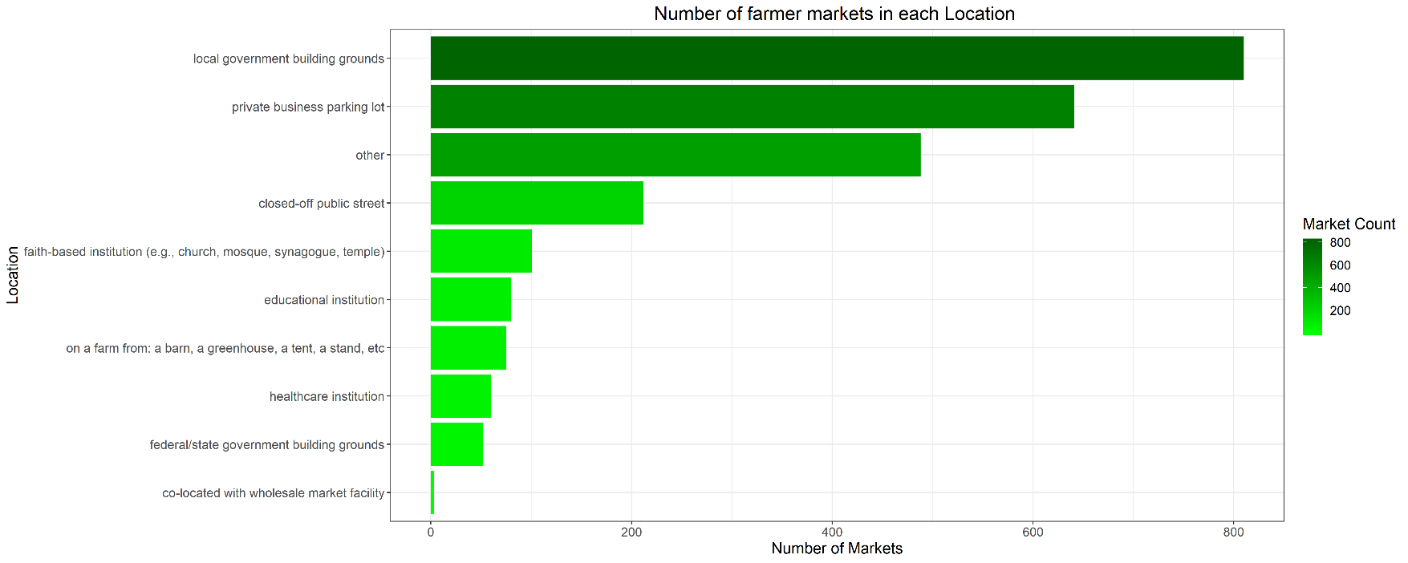

**Insights on Farmers Markets registered**

**Farmers Markets registered per year**

1.From the below graph around 1000 graphs are registered in the year 2014 which is also the highest when compared with any other year

2.Apparently 2020 can be neglected as the year has just started

3.Followed by 2014 ,2016 stands next in the number of Markets registered which may range between 900-1000

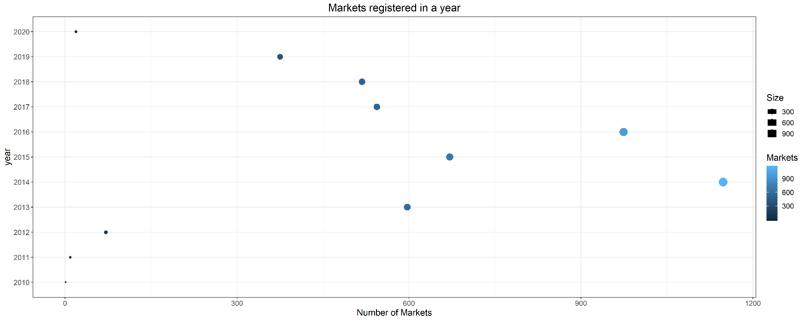

**[2]Assumptions**

**Insights Based on payment systems**

NUMBER OF STORES ACCEPTING THE DIFFERENT PAYMENT METHODS IN EACH REGION

1. The below Dot plots shows different payment methods in each region
2. As per the below plot, the number of stores accepting all kinds of payment methods is high in Mid-West region except wiccash payment where Mid-Atlantic has the highest number of stores which accepts wiccash methods.
3. Apart from the Us territories, South-west region stands low in all the payment methods.
4. By this we can conclude that the farmers markets in mid-west region are supporting the grants programs (SNAP, WIC, WICCASH, SFMP) implemented by the US Government

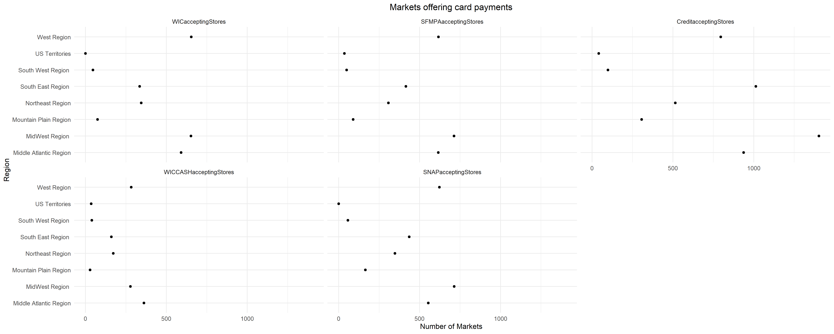

NUMBER OF STORES ACCEPTING ALL KINDS OF SUBSIDARY PAYMENTS

1. Below Bar-graph shows the stores that accept all kinds of subsidiary payments per state.
2. New-York has the maximum number of stores that accept all kinds of payments apart from credit payment [3]
3. states have more stores that accept all kind of subsidiary payments than nations average i.e. 14

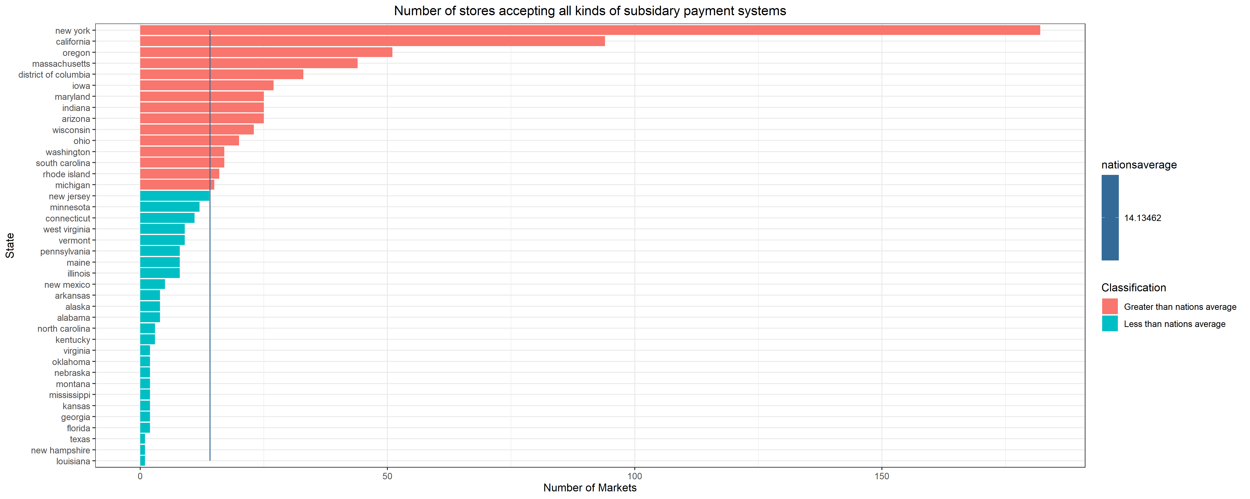

SALE OF PRODUCTS IN THE MARKETS FOR EACH REGION BY CATEGORY

1. In the below graph, products have been categorized[4] according to their type.
2. Canned, plant based & Food products are mostly sold in Midwest region and least sold in US territories and south-west region
3. Organic food is sold least in all the regions followed by home needs.
4. Almost all the products are sold highly in Midwest region

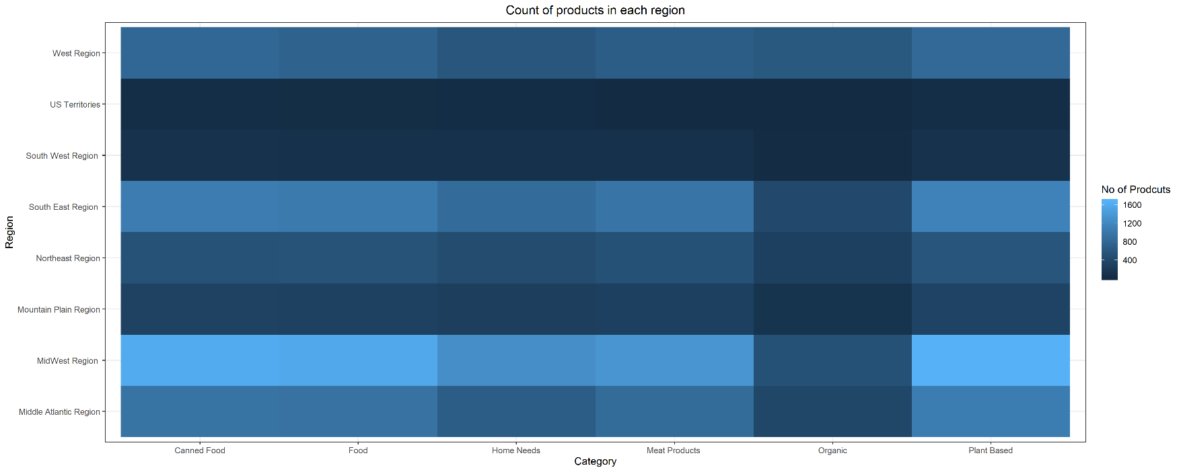

Insights from the below report provided on grants allocated

From the below insights, even though the grants are mostly allocated to west region, the items sold in the west region are relatively low when compared with Mid-West and South-East regions.

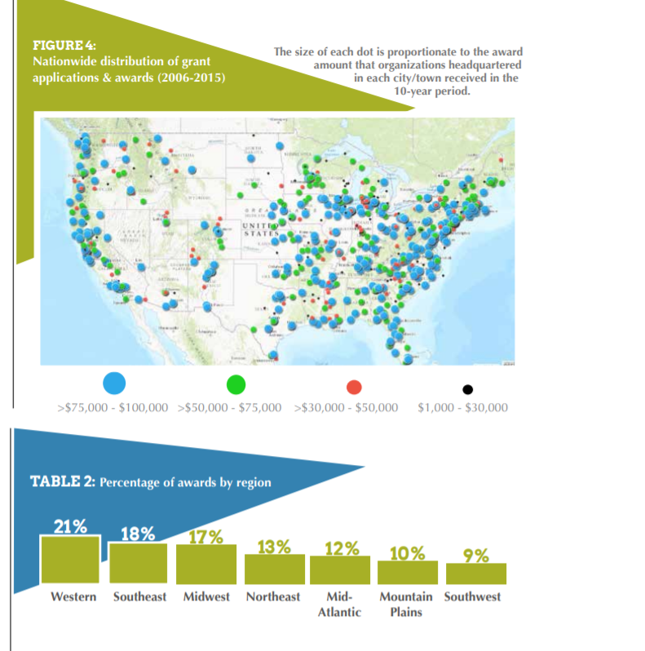

CLASSIFYING THE FARMER MARKETS ACCORDING TO THE NUMBER OF PRODUCTS AVAILABLE TO SELL IN EACH MARKET

1. The below plot shows the classification of markets in to Large medium and small scales.
2. Markets that sells more than 20 products have been named as large scale and markets that sells between 10 and 20 products were named as Medium scale, followed by Small scale i.e. less than 10 products
3. From the below analysis there are many Medium scale markets when compared with Large and Small scale

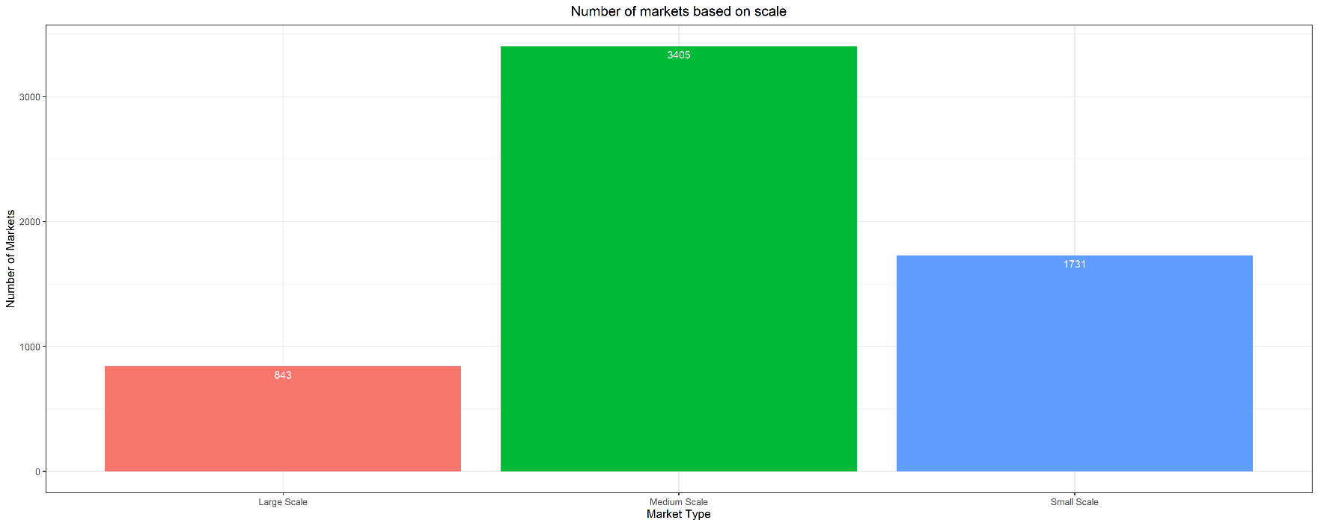

**INSIGHTS ON SOCIAL MEDIA AVAILABILITY**

PLOT ON NUMBER OF MARKETS THAT USE THE SOCIAL MEDIA

1. The Dot Plot shows the markets that use social medial accounts and websites.
2. In almost all the regions most of the markets have websites than any other social media accounts.
3. Most of the stores don’t have the YouTube accounts which stood least of all the categories.
4. Follwed by websites, most of the markets have Facebook accounts associated with the market.

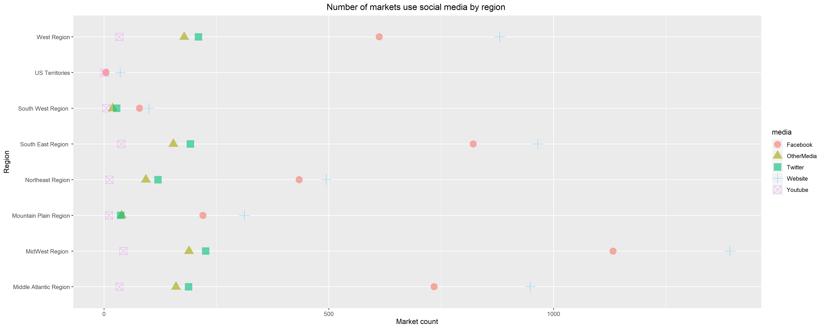

**Grants allocated for senior farmers market nutrition program [5]**

1. From the below line graph, we can analyze that the grants have been disbursed more in middle-Atlantic region whereas southwest stands lowest of all.
2. Of all the years in 2013, high amount is distributed when compared to other years.

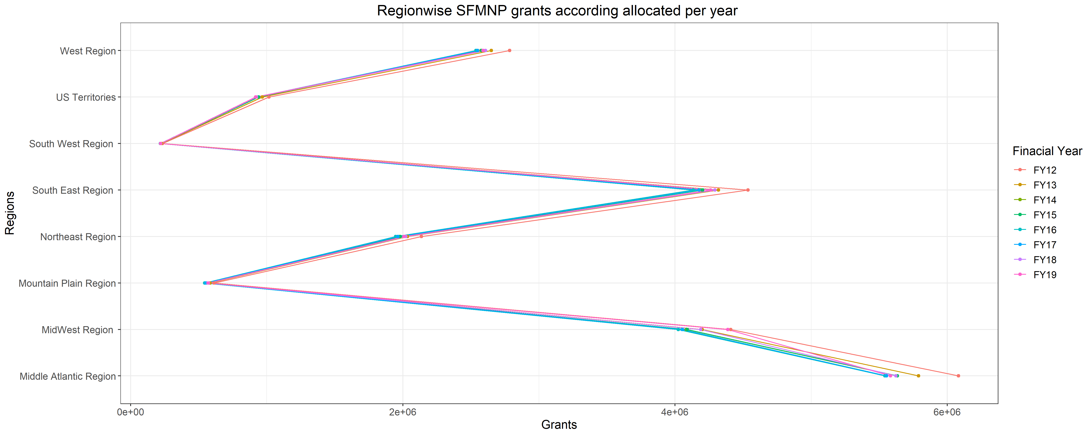

**Count of markets selling each type of product**

1. It is evident that vegetables are the highest sold products
2. Almost over 5000 markets are selling vegetables and baked goods
3. Tofu is sold in fewer number of markets

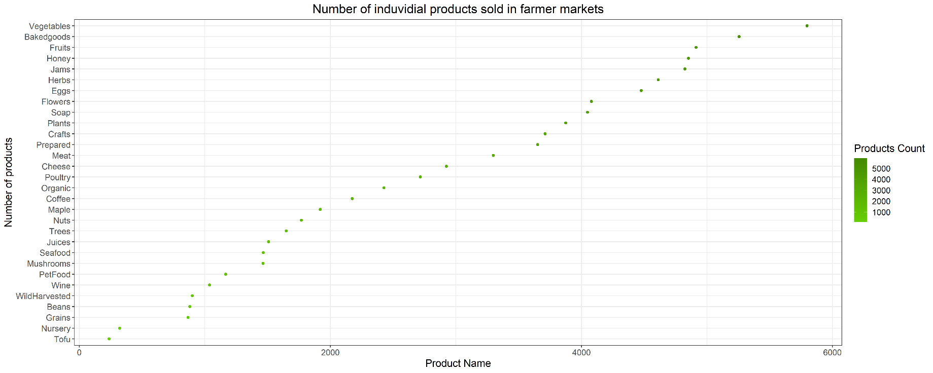

1. source:<https://www.worldatlas.com/articles/10-us-states-with-the-highest-number-of-farms.html>
2. Here the season1 data has been considered as the year by which the markets has been registered in the database
3. Removed credit payments as they are not the government provided subsidiaries
4. Canned food : Honey, Jams, Maple, Nuts, Prepared, Beans, Mushrooms, PetFood.

   Food: Bakedgoods, Cheese, Fruits , Grains , Juices, Tofu .

   Home Needs: Soap, Coffee.

   Meat Products: Eggs, Seafood, Meat, Poultry.
5. <https://fns-prod.azureedge.net/sites/default/files/resource-files/SFMNP-Grant-Amounts.pdf>